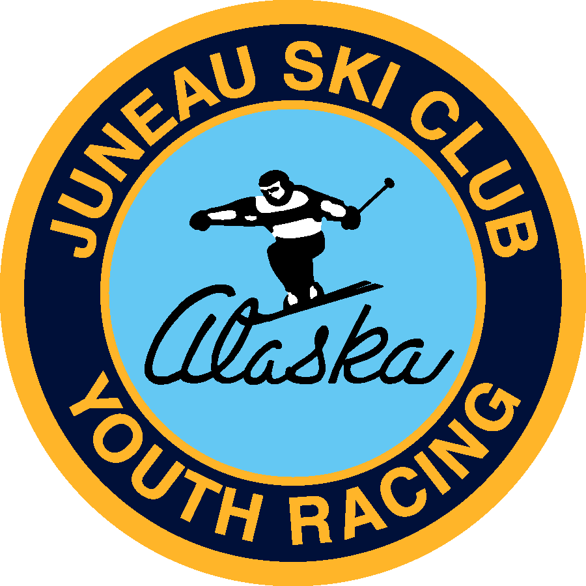 |  |  |  | 2020/2021 Sponsorship  - Be a part of juneau-douglas ski tradition  Dear Local Business Representative,  Juneau Ski Club (JSC) is a youth alpine ski racing program with a long-standing tradition in our community. In fact, it was first incorporated in 1935 and was the founding precursor to our local ski area that we know as Eaglecrest today.  JSC has helped young athletes excel at the art of skiing and many of our athletes have gone on to be excellent skiers, win scholarships for college, been in various ranks of the U.S. Ski Team, competed on the world stage at free skiing events, and even won a medal at the Olympics!  None of this would have been possible through the years without the support of our small but unique and generous community and local businesses support. When you pledge your support to the Juneau Ski Club and its athletes, you are telling the community that you believe in our kids and want to help them excel. In return we have excellent ways of acknowledging and promoting your business both on and off the mountain.  All donations are 100% tax deductible as we are a 501c3 non-profit. Depending on your level of support, your company will be enjoying prominent visibility and recognition throughout the year. Please take a moment to consider the levels of sponsorship and support for our youth athletes.  The Juneau Ski Club is very flexible and would love to discuss any and all options, ideas, trade, comments and/or question you may have with your regard to supporting JSC.  Sincerely,  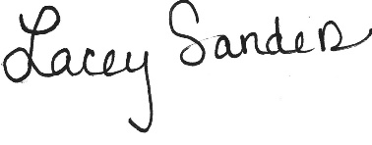  Lacey Sanders  2020 Juneau Ski Club President
 | C O N T A C T
juneauskiclubbod@gmail.com
907-790-RACE
www.juneauskiclub.com
PO Box 32358
Juneau, AK 99803
This program is partially funded by the citizens of the City and Borough of Juneau through the Youth Activity Grant program. JSC applies for these competitive grant funds annually.

2020/2021 Sponsorship levels
support the juneau ski CLUB AND show your community spirit
-
$50 - $499 |  | 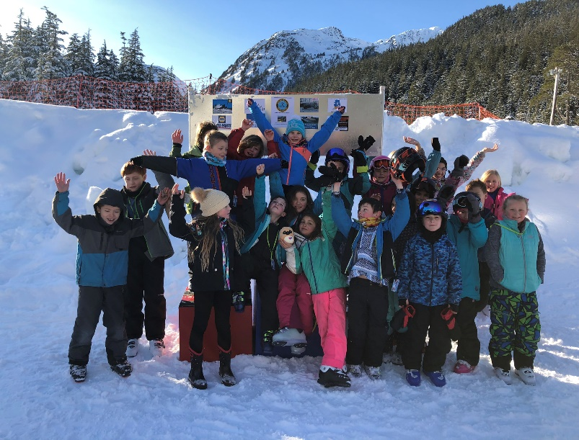
Mitey Mites Sponsor Level
Number
JSC decal and thank you sponsorship signage.
Name listed on sponsorship page on JSC website.
Name listed on Social Media Sponsorship posts.
$500 - $999 |  | $500 + In-Kind Trade
DEvos sponsor level  Number |  | Freeride Sponsor level  Number
JSC decal and thank you sponsorship signage. |  | JSC decal and thank you sponsorship signage.
Logo on sponsorship page on JSC website. |  | Logo hyperlink on sponsorship page on JSC website.
Name listed on Social Media Sponsorship posts. |  | Full color sign on JSC Finish Shack at Eaglecrest.
Name listed on Sponsorship Sign in JSC Race Room.
If your business has goods and services you would like to discuss regarding this package,
please contact us.
Name and Logo posted on Award Podium Halo.

$1,000 and Up
Juniors sponsor level
Number
 |  | 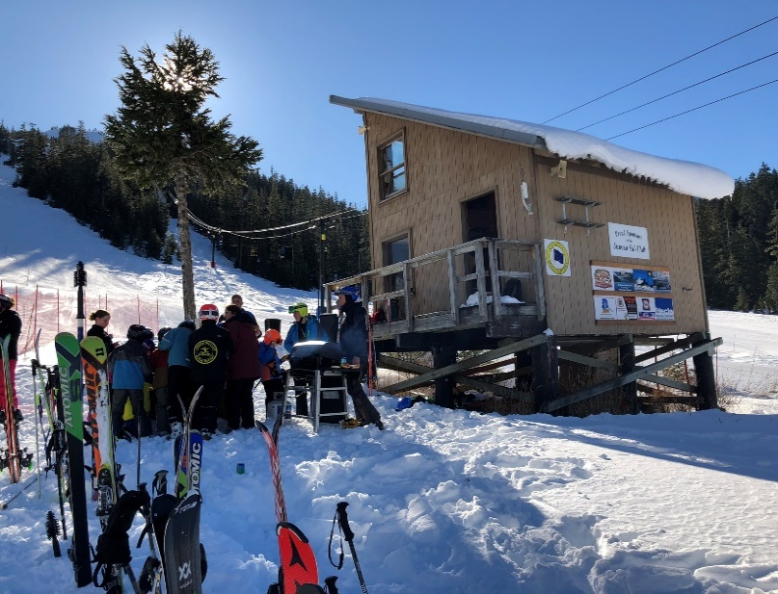
JSC decal and thank you sponsorship signage.
Logo hyperlink on sponsorship page on JSC website.
Name listed on Social Media Sponsorship posts.
Name listed on Sponsorship Sign in JSC Race Room.
Name and Logo posted on Award Podium Halo.
Full color sign on JSC Finish Shack at Eaglecrest.
Name and tagline included on race day. announcements.

